**Project Design Phase-II**

**Data Flow Diagram & User Stories**

|  |  |
| --- | --- |
| Date | 06 May 2023 |
| Team ID | NM2023TMID04500 |
| Project Name | Blogging: Create a blog using Wordpress |

**Data Flow Diagrams:**

A Data Flow Diagram (DFD) is a traditional visual representation of the information flows within a system. A neat and clear DFD can depict the right amount of the system requirement graphically. It shows how data enters and leaves the system, what changes the information, and where data is stored.

**Data Flow diagram :** 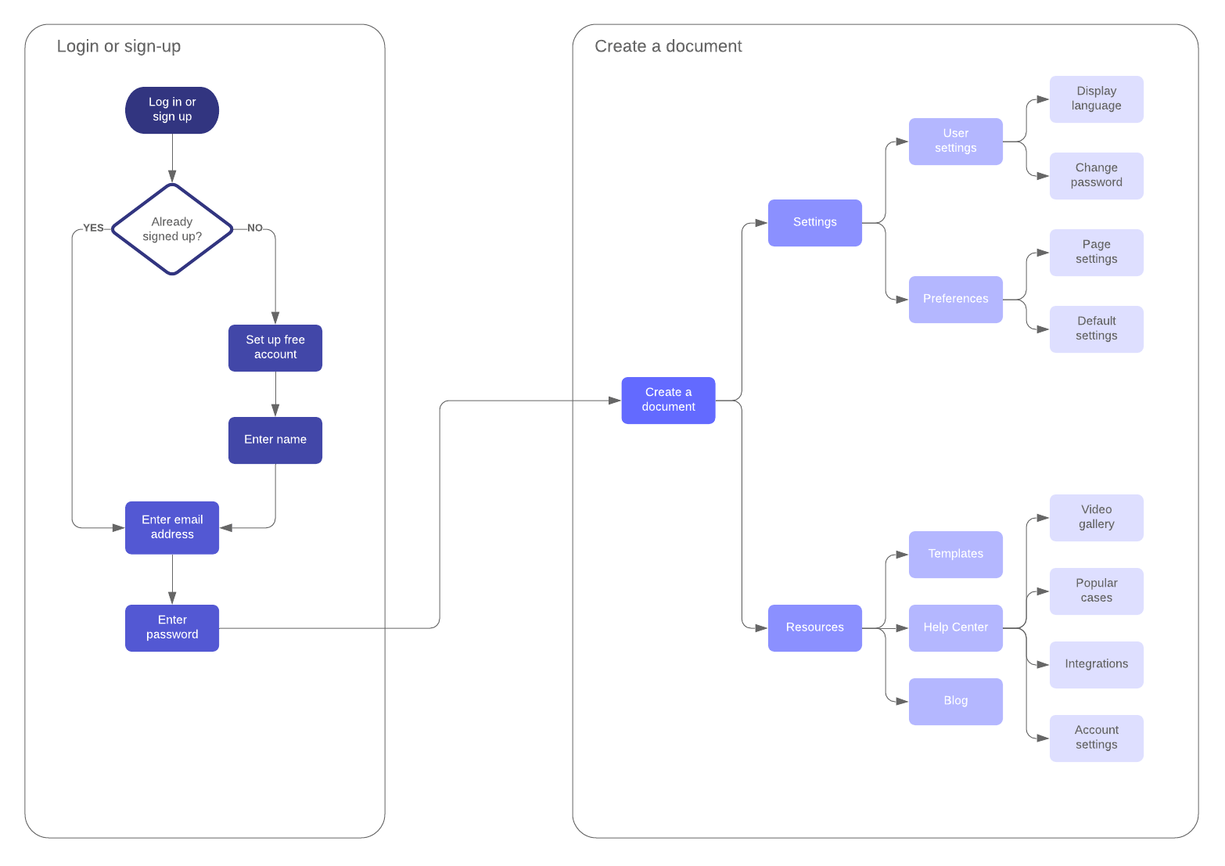

**User Stories**

|  |  |  |  |  |  |  |
| --- | --- | --- | --- | --- | --- | --- |
| **User Type** | **Functional**  **Requirement**  **(Epic)** | **User Story Number** | **User Story / Task** | **Acceptance criteria** | **Priority** | **Team Member** |
| Novice Trader | User education | US001 | As a novice trader, I want access to beginner-friendly educational content to understand trading fundamentals. | I can navigate to the "Education" section.  I can access articles and videos explaining trading basics.  The content is clear and easy to understand. | High | Jeeva Ananth |
|  | User Education | US002 | As a novice trader, I want to test my trading knowledge through quizzes to reinforce my learning. | I can find and take trading quizzes in the "Education" section.  Quiz questions cover the topics I've learned.  I receive immediate feedback on quiz results. | Medium | Sanjay |
| Community Builder | Community Engagement | US003 | As a community builder, I want to start a discussion on a trading topic I'm passionate about. | I can create a new discussion thread in the community forum.  I can add tags to categorize my discussion.  Other users can join and participate in the conversation. | High | Gokul |
| Branding Enthusiast | Branding Customization | US004 | As a branding enthusiast, I want to customize my user profile by adding a unique avatar image. | I can upload a personalized avatar image.  The image is displayed on my profile. | Medium | HariHaran |